Design Documentation of A Simple Distributed Hash Table

CONTENTS

1. Distributed Hashing Server
2. Client
3. Trade Off
4. Other files
5. Future Scope
6. Design diagram
___________________________________________________________________________________
1. Distributed Hashing Server :
This is distributed hash table implementation. The server here is running on several machines instead of 1 machine. A hash function decides, which value to be stored on which server. Data resilience is provided by storing DHT status after each operation performed by server.
Operations :
A. put
This operation allows to store the {key,value} pair in DHT
B. get
This operation allows to view the value of a key in DHT
C. del
Given the key, this operation allows to remove entry of a {key, value} pair in DHT
As the server is distributed, even if one or two server fails, entire system would not get discarded. Also the data resilience ensures, even after failure, when the server restarts, the previous data will be recovered.
___________________________________________________________________________________
2. Client
Client is capable of performing all the operations. He need not to worry about where the data is going to be stored on the network. The client program will take appropriate input from user and connect to the respective Hashing Server. As there are 8 servers running on the network, each of client's request can be processed by 1 of the 8 servers, regardless of it's previous or next requests. Hence data dependency is resolved. This also utilizes the latency time between request and response.
Operations:
A. Request
Client will take requests from the user and send it to appropriate server.
B. Hash Calculation
Depending on the Key of operation, client will connect or check for the existing connection with the appropriate server. Then client will send the request to that server.
C. Response
After receiving response from the server, client will display that response to the user.
___________________________________________________________________________________
3. Trade Off
To achieve better performance, we have used distributed servers. However, the limit of servers is set to 8. In order to avoid memory overflows, we have limit the size of Key to 24 bytes and size of value to 1000 bytes. Entire idea of implementing a DHT is to achieve data security. While allowing DHT to work on 8 different nodes, to achieve this data security, we are saving the DHT status after each single put() or del(). It involves operations like, create a file on disk and save current status of DHT in it. These file operations are going to bring down the performance as saving the data on disk after each operation is going to consume some time. For single operation or some thousands of operations, it is very less. However, as the requests grows, this time gets added in proportion. This trade off was made, as data security was given more priority over time requirements during design of the system.
___________________________________________________________________________________
4. Other files
A. HashtableServer#.txt
This file is created at each ith server for saving the status of DHT. When running for first time, this file will be created newly. If server somehow restarts, the data will be recovered by reading contents of this file. For Server 3, the file name will be HashtableServer3.txt
B. config.txt
All the properties of network are stored in this file. This file must be present in order to successfully run both client and server. In absence of this file, following error will be thrown :
Connection properties file is not given. Please give properties file.
___________________________________________________________________________________
5. Future Scope
We can add system logs at each stage of this program. So if a failure occures, this log can in detail tell us about what are the bugs or where the patches are required. Also, for enhanced security, we can have encryption and decryption mechanisms implemented at client and server server ends. So keys and values will be securely shared over the network.
___________________________________________________________________________________

6. Design diagram
A. Architecture Diagram:
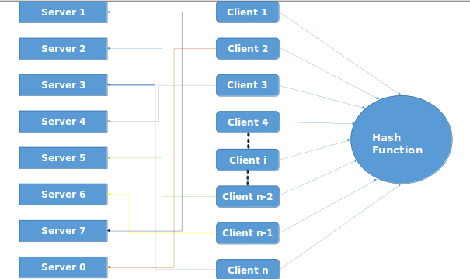

B. Sequence Diagram:
